**Pentecost 19 11 October 2020**

**And the peace of God, which surpasses all understanding, will guard your hearts and your minds in Christ Jesus.** Philippians 4:7

Come, join the celebration of God.  
***Here we are enabled to leave the anxieties of our daily lives behind.***Yes! We carry all that is our reality and our true being and place it in the welcoming hands of God for the Christ receives the real us with gladness.  
***We are invited.  
We are the people chosen to gather as God’s faithful ones  
for God has open arms and waits in anticipation for us.  
Praise be God!***

**Hymn 686** *Lord Jesus, we belong to you,  
 you live in us, we live in you;  
 we live and work for you –  
 because we bear your name.*

*Help us receive each other, Lord,  
 for you receive the least of us  
 and come to us in them -   
 because we bear your name.*

*Bless those who give us any gift  
 because they know that we are yours;  
 reward them with your grace -  
 because we bear your name.*

*Let nothing that we do or say  
 offend the weak so that they fall  
 and lose their faith in you -  
 because we bear your name.*

*Keep us from missing out on life;  
 give hands that help; and single sight,  
 and feet that walk your way -   
 because we bear your name.*

*You are the salt that cleanses us,  
 so clean us out and make us fit  
 for common life with you -   
 because we bear your name.*

**Opening Prayer**O God, your steadfast love is always there for us;  
***there in times of joy and certainty,  
there when the testing times come.***O God, your steadfast love is always there for us;  
***there when despair and apathy grips us,  
there when doubt and uncertainty in the face of life’s challenges is all we seem to know.***O God, your steadfast love is always there for us;  
***there in our solitary moments as in our pandemic isolation, there when we hunger for the comfort of our faith community and its comfort and support;***O God, your steadfast love is always there for us;  
***there when we are in familiar territory, there as we venture into unchartered waters and times of great risk.***O God, your steadfast love is always there for us;  
Your love in Christ our Lord never leaves us  
***and your peace surpasses all understanding guarding our hearts and minds for ever.  
Amen***

**Confession and Assurance**O Lord revealtous that which lies silently in the shadow of our hidden lives and which we fear to expose to the light of your life, anxious in case we are condemned or asked to change beyond our capacities and desires.  
***Speak to our hearts, O God our Redeemer. Remind us yet again of your invitation to the abundant resurrection life that is ours in Christ our Lord.***Forgive us if we have not opened your feast of life to others, excluding them from the invitation by our mean-spirited judgementalism and discouraging them from feeling welcome by our decisions about who is worthy in your presence.  
***Speak to our hearts, O God our Redeemer. Remind us yet again of your invitation to the abundant resurrection life that is ours in Christ our Lord.***Forgive us when we take for granted our place at your table, failing to remember the wonder of the generosity of the invitation to the Wedding Feast in the gospel story of long ago and the costliness of its grace to all. Hear the Gospel.

**Gospel Matthew 22:1-14  
 And again Jesus spoke to them in parables, saying, "The kingdom of heaven may be compared to a king who gave a wedding feast for his son, and sent his servants to call those who were invited to the wedding feast, but they would not come. Again he sent other servants, saying, 'Tell those who are invited, See, I have prepared my dinner, my oxen and my fat calves have been slaughtered, and everything is ready. Come to the wedding feast.'**

**But they paid no attention and went off, one to his farm, another to his business while the rest seized his servants, treated them shamefully, and killed them. The king was angry, and he sent his troops and destroyed those murderers and burned their city. Then he said to his servants, 'The wedding feast is ready, but those invited were not worthy. Go therefore to the main roads and invite to the wedding feast as many as you find.' And those servants went out into the roads and gathered all whom they found, both bad and good. So the wedding hall was filled with guests.**

**"But when the king came in to look at the guests, he saw there a man who had no wedding garment. And he said to him, 'Friend, how did you get in here without a wedding garment?' And he was speechless. Then the king said to the attendants, 'Bind him hand and foot and cast him into the outer darkness. In that place there will be weeping and gnashing of teeth.' For many are called, but few are chosen."** This is the gospel of the Lord.  
 ***Praise be to you, Lord Jesus Christ.***

Listen. Listen deep in the quiet places of your souls Receive the grace of God and be open to its invitation for we are forgiven. So we bring our thanks to God:  
Thanks for forgiveness when we do not deserve it, thanks for kindness when we are rarely as kind to others, thanks for inclusion in the celebration of the life of God when we are often lacking in spontaneous celebration.  
***Thanks be to God for all the gifts that are ours as his faithful people!***Thanks for understanding when we do foolish things and for wisdom which comes in unexpected gifts.  
Thanks for endless patience, O God, which means that you return to us again and again when we are paralysed by fear and uncertainty or the inability to face the truth.  
***Thanks be to God for all the gifts that are ours as his faithful people!  
Amen***

**Hymn** *Chorus:  
 I cannot come to the banquet, I cannot come to the banquet,  
 don't trouble me now.  
 I have married a wife; I have bought me a cow.  
 I have fields and commitments that cost a pretty sum.  
 Pray, hold me excused, I cannot come.*

*1. A certain man held a feast on his fine estate in town.  
 He laid a festive table and wore a wedding gown.  
 He sent invitations to his neighbours far and wide  
 but when the meal was ready, each of them replied:*

*2. The master rose up in anger, called his servant by name,  
 said: "Go into the town, fetch the blind and the lame,  
 fetch the peasant and the pauper, for this I have willed,  
 my banquet seem so crowded, and my table must be filled.*

*3. When all the poor had assembled, there was still room to spare,  
 so the master demanded: "Go search every where,  
 to the highways and the byways and force them to come in.  
 My table must be filled before the banquet can begin.*

*Now God has written a lesson for the rest of the mankind;  
 If we're slow at responding, he may leave us behind.  
 He's preparing a banquet for that great and glorious day  
 when the Lord and Master calls us, be certain not to say:  
 I cannot come to the banquet, I cannot come to the banquet,  
 don't trouble me now.  
 I have married a wife; I have bought me a cow.  
 I have fields and commitments that cost a pretty sum.  
 Pray, hold me excused, I cannot come.*

**Reflection**The Kingdom of God – here identified with such a celebration as a wedding feast – is absolutely a joyous event and one always there awaiting God’s faithful people. But it is a moment by moment invitation, not a once in a lifetime choice. So Kingdom living, resurrection life, is the life into which we are constantly being invited. But, as such it is also the life that even God’s faithful will turn their backs on and refuse to enter into at times because, as was the way of the Israelites of old, we human beings can be contrary people, people who refuse to stick with what we have found in the past as good and of God. We can waver in commitment and hanker for a less demanding past with our hearts not truly in the reality that is kingdom living, not seeing the full reality of the compassion of God that is ours when we fully accept what he is for us in resurrection life. And so, like the guest who came without wearing wedding clothes, we miss the point of the occasion, we misunderstand what is the truth of the reign of God for us. As we recall the failings of the Hebrew people in their desert sojourn long ago and their lapsing into a preferred past, the cartoonist captures the backsliding with his humour.

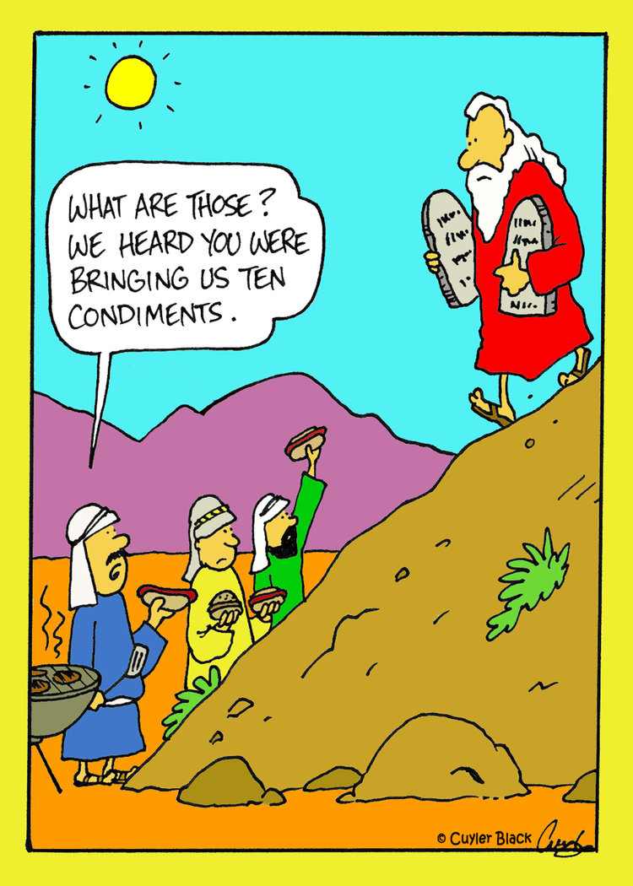

**Hebrew Scripture** **Exodus 32:1-14  
 When the people saw that Moses delayed to come down from the mountain, the people gathered themselves together to Aaron and said to him, "Up, make us gods who shall go before us. As for this Moses, the man who brought us up out of the land of Egypt, we do not know what has become of him.” So Aaron said to them, "Take off the rings of gold that are in the ears of your wives, your sons, and your daughters, and bring them to me." So all the people took off the rings of gold that were in their ears and brought them to Aaron. And he received the gold from their hand and fashioned it with a graving tool and made a golden calf. And they said, "These are your gods, O Israel, who brought you up out of the land of Egypt”. When Aaron saw this, he built an altar before it. And Aaron made proclamation and said, "Tomorrow shall be a feast to the Lord." And they rose up early the next day and offered burnt offerings and brought peace offerings. And the people sat down to eat and drink and rose up to play.**

**And the Lord said to Moses, "Go down, for your people, whom you brought up out of the land of Egypt, have corrupted themselves. They have turned aside quickly out of the way that I commanded them. They have made for themselves a golden calf and have worshiped it and sacrificed to it and said, 'These are your gods, O Israel, who brought you up out of the land of Egypt!' And the Lord said to Moses, "I have seen this people, and behold, it is a stiff-necked people. Now therefore let me alone, that my wrath may burn hot against them and I may consume them, in order that I may make a great nation of you."**

**But Moses implored the Lord his God and said, "O Lord, why does your wrath burn hot against your people, whom you have brought out of the land of Egypt with great power and with a mighty hand? Why should the Egyptians say, 'With evil intent did he bring them out, to kill them in the mountains and to consume them from the face of the earth'? Turn from your burning anger and relent from this disaster against your people. Remember Abraham, Isaac, and Israel, your servants, to whom you swore by your own self, and said to them, 'I will multiply your offspring as the stars of heaven, and all this land that I have promised I will give to your offspring, and they shall inherit it forever.'” And the Lord relented from the disaster that he had spoken of bringing on his people.** In this is the word of the Lord.  
 ***May it bear much fruit in us.***

**Hymn 249** *No weight of gold or silver  
 can measure human worth;  
 no soul secures its ransom  
 with all the wealth of earth;  
 no sinners find their freedom  
 but by the gift unpriced,  
 the Lamb of God unblemished,  
 the precious blood of Christ.*

*In Christ the past is over,  
 a new world now begins.  
 With him we rise to freedom  
 who saves us from our sins.  
 We live by faith in Jesus  
 to make his glory known:  
 behold, the man of sorrows,  
 the Lamb upon his throne.*

**Epistle  
 Finally, brothers, whatever is true, whatever is honourable, whatever is just, whatever is pure, whatever is lovely, whatever is commendable, if there is any excellence, if there is anything worthy of praise, think about these things. *Philippians. 4:8***

**Prayers for Ourselves and Others and Lord’s Prayer**O God of true welcome, holy gatherer of the lost and uncertain, the One bringing all who would come into the safe haven of your love; the One who creates the eternal celebration of life in the face of all our struggles and failures, we pray to you this day.  
Especially we pray for all who have little experience of welcome:  
***Receive our prayers and make us part of your answer.  
Open our hearts to such as those who are excluded for whatever reason, be it prejudice or disdain on our part.  
Create together with us a celebration of life in community and in faith, raw and real so that everyone has a place and feels at home.***Give to us a new sense of celebration and joy in our lives, recognising the reality of our pain and despair especially that of isolation, yet lifting high in hope those times of survival against the odds and always open to the wonder of your resurrection life in the Christ among us.

***Make us worthy to be called your faithful people, O God.  
Stay with us when our footsteps falter and recreate the feast of life among us in each day.  
So we now pray the kingdom prayer of our Lord***

***Our Father in heaven,  
hallowed be your name,  
your kingdom come,  
your will be done,  
on earth as in heaven.  
Give us today our daily bread.  
Forgive us our sins  
as we forgive those who sin against us.  
Save us from the time of trial  
and deliver us from evil.  
For the kingdom, the power, and the glory are yours  
now and for ever.  
Amen***

**Hymn 544** *Since the world was young  
 there’s a song that’s been sung  
 of a promise coming true;  
 hungry folk will eat  
 and long- lost friends will meet  
 and the Lord will make all things new.*

*God has a table  
 where he calls his friends  
 to a feast that never ends;  
 God has a table  
 and one day we will meet him there.*

*Jesus told a tale  
 of how rich people fail  
 to accept God’s summons to dine.  
 Then before their eyes  
 those without earthly ties  
 share heaven’s finest food and wine.*

*God has a table  
 where he calls his friends  
 to a feast that never ends;  
 God has a table  
 and one day we will meet him there.*

*Till we hear that word  
 from the mouth of the Lord  
 saying, ‘Join me at my table’,  
 for the world we’ll care  
 and its good things we will share  
 as long as we are able.*

*God has a table  
 where he calls his friends  
 to a feast that never ends;  
 God has a table  
 and one day we will meet him there.*

**Benediction** And the peace of God, which surpasses all understanding,  
 will guard your hearts and your minds in Christ Jesus  
 our risen reigning Lord.  
 ***Amen***

**Reverend Graeme Kerr**