**Advent Sunday 29 November 2020**

**Grace to you and peace from God our Father and the Lord Jesus Christ. God is faithful, by whom you were called into the fellowship of his Son, Jesus Christ our Lord.** 1 Cor. 1:3 ,9

Watch, wait and hope! For the wonder of new love is moving towards its birthing in the spirit of Advent. We look for the signs of that which is to come, held within our midst in promises of joy and unfailing hope***.  
Come gracious Jesus, come.***

**Hymn 290** *Of the Father’s love begotten  
 ere the world began to be,  
 he is Alpha and Omega,  
 he the source, the ending he,  
 of the things that are, that have been,  
 and that future years shall see  
 evermore and evermore.*

*O that birth for ever blessed  
 when the virgin, full of grace,  
 by the Spirit’s power conceiving  
 bore the saviour of our race,  
 and the babe, the world’s redeemer,  
 first revealed his sacred face,  
 evermore and evermore.*

*This is he whom seers and sages  
 sang of old with one accord,  
 whom the voices of the prophets  
 promised in their faithful word;  
 now he shines, the long-expected:  
 let creation praise its Lord  
 evermore and evermore.*

*In the heights of heaven adore him,  
 angel hosts his praises sing,  
 all dominions bow before him  
 and extol our God and king;  
 let no tongue on earth be silent,  
 every voice together sing  
 evermore and evermore.*

**Confession and Assurance**Ever loving God, weknow that we do not listen for your word as we should. We confuse your word with ours and bow to ideas which seem to better suit us and we allow others to divert our faithfulness and threaten us with your judgement when we should be opening ourselves to your unfailing love.  
***Be present in our listening and watching, Jesus Christ as we look forward once again for your coming to us.***Often we long for instant solutions to issues which arise in our lives, refusing to pause and pray and remain open to your truth.  
***Be present in our listening and watching, Jesus Christ as we look forward once again for your coming to us.***When we are so impatient that we decide what your Word will look like even before it comes to us; when we cannot allow its reality in a newborn baby and re-imagine it in an image of our making rather than honouring God’s choice of his presence among us:  
***Be present in our listening and watching, Jesus Christ as we look forward once again for your coming to us.***O God, we know that hope is often hard to hold if it is not present in human dimensions of power and force; the innocence of a child as the real presence and promise of your faithfulness seems too far-fetched to bring us to faithfulness in the harsh reality of the world in which we live:  
***Be present in our listening and watching, Jesus Christ as we look forward once again for your coming to us.***

**Assurance**The promises of God are wider than the oceans of his creation, deeper than the depths of the earth itself and higher than the heavens above. The gracious gift of a child cradled in a manger through the action of God in his creation will not fail us. We thank you, gracious and loving God, for the amazing testimony of the Christ born among us and its clarion affirmation among us, ringing down the ages, challenging all our doubts and fears and behind which speaks the authority born of costly life, from its beginnings to its risen endings.  
***Amen***

**Hymn 197** *God’s Son came to bless us,  
 from sin to release us,  
 as a servant lowly,  
 yet our God most holy,  
 bore the cross to save us,  
 hope and freedom gave us.*

*Still Christ comes within us,  
 still his voice would win us  
 from the sins that hurt us,  
 would to truth convert us;  
 from our folly spares us,  
 and his own declares us.*

*So, as you have known him,  
 be prepared to own him;  
 do not spurn him coldly,  
 but still trust him boldly;  
 for our Lord receives us,  
 heals us, and forgives us.*

O Lord, may your word live in us  
***and bear much fruit to your glory***

**Scripture Isaiah 64:1-9  
Oh that you would rend the heavens and come down, that the mountains might quake at your presence— as when fire kindles brushwood and the fire causes water to boil— to make your name known to your adversaries, and that the nations might tremble at your presence!  
When you did awesome things that we did not look for, you came down, the mountains quaked at your presence.  
From of old no one has heard or perceived by the ear, no eye has seen a God besides you, who acts for those who wait for him.  
You meet him who joyfully works righteousness those who remember you in your ways. Behold, you were angry, and we sinned; in our sins we have been a long time, and shall we be saved?  
We have all become like one who is unclean, and all our righteous deeds are like a polluted garment.  
We all fade like a leaf and our iniquities, like the wind, take us away.  
There is no one who calls upon your name, who rouses himself to take hold of you; for you have hidden your face from us, and have made us melt in the hand of our iniquities.  
But now, O Lord, you are our Father; we are the clay, and you are our potter; we are all the work of your hand.  
Be not so terribly angry, O Lord, and remember not iniquity forever.  
Behold, please look, we are all your people.** In this is the word of the Lord.  
 ***Thanks be to God***

**Gospel Mark 13:33-37  
“Be on guard, keep awake. For you do not know when the time will come. It is like a man going on a journey, when he leaves home and puts his servants in charge, each with his work, and commands the doorkeeper to stay awake. Therefore stay awake—for you do not know when the master of the house will come, in the evening, or at midnight, or when the cock crows, or in the morning—lest he come suddenly and find you asleep. And what I say to you I say to all: Stay** **awake."** This is the gospel of the Lord.  
 ***Praise to you, Lord Jesus Christ***

**Reflection**As we now move into the waiting and reflective period that is Advent, we receive the assurance that, whatever life looks like for us, even in this turmoil of Covid and its shaking of our most trusted foundations, the Word that is the Christ among us is still to be trusted. God is never far away from us. So, yes, we are to look for vulnerable signs of new possibilities as the arrival of a newborn presents new hope and a new future.  
And now we should be asking ourselves whether we are prone to look for larger and more comprehensive signs of God’s activities in our lives and in the world; do we wait for the dramatic rather than build upon less obvious encouragement and hope? Does not the birth of a child in a manger bring us to look for God’s arrival in our ongoing lives as lying in each and every moment of our experiences rather than in some distant huge encounter? ”Stay awake!“ is not a command involving an indeterminate future but a word for here and now.

**Hymn 265** *O come, O come, Emmanuel,  
 and ransom captive Israel,  
 that mourns in lonely exile here  
 until the Son of God appear.* ***Rejoice! Rejoice!  
 Emmanuel shall come to you, O Israel****.*

O come, O come, great Lord of might  
 who to the tribes on Sinai’s height  
 in ancient times did give the law  
 in cloud and majesty and awe.  
 ***Rejoice! Rejoice!  
 Emmanuel shall come to you, O Israel****.*

*O come, O key of David, come,  
 and open wide our heavenly home;  
 make safe the way that leads on high  
 and close the path to misery.*  ***Rejoice! Rejoice!  
 Emmanuel shall come to you, O Israel****.*

*O come, O branch of Jesse, free  
 your own from Satan’s tyranny;  
 from depths of hell your people save  
 and give them victory o’er the grave.*  ***Rejoice! Rejoice!  
 Emmanuel shall come to you, O Israel****.*

*O come, O dayspring, come and cheer  
 our spirits by your advent here;  
 disperse the gloomy clouds of night  
 and death’s dark shadows put to flight.*  ***Rejoice! Rejoice!  
 Emmanuel shall come to you, O Israel****.*

**Concluding Reflection** That great hymn with which we began today is an affirmation of the path of our worship in isolation throughout this challenging year of pandemic. For as we have moved through the salvation history drama of the evolution of faith through the nomadic searching of Abraham and his recognition of God as one who promises a special future through the journey of faith; and as Abraham’s descendants move on to become Israel and to inherit the faith promise made to their forefather, Abraham; so the destiny of humanity has found its resolution in a man in whom God chose to become the fulfilment of the promise to Abraham and the ultimate resolution of the journey of faith; a man whose full experience of the human condition of life, death and resurrection was to be the quantum leap into a new reality not just for humankind but for all creation. Yes, Advent is a time to renew our focus on the God in whom we believe. It is a time to make, once again, the quantum leap of faith that is embraced in the final resolution that is justification by faith alone and to know that what we as Christians now experience is God’s final evolution for his world, the end and beginning of his reality for us, the life of the Kingdom.  
 The ancient stories and the amazing saga that saw Israel advancing its history on a path to a new future through Jacob’s son, Joseph and his amazing technicolour dreamcoat was to find particular fruition in Moses, the Hebrew man raised by an Egyptian princess and who found himself encountered by God in a sacred engagement and a new moment of epiphany in a bush that was burning but not consumed continued with far reaching consequences for the outworking of the ancient promise to the Patriarch, Abraham, and the fulfilment in a crucified man and his resurrection life in a far off future that has become our present.  
 As we mark Advent and the birth of the Christ child we prepare again to explore the underlying question of “who and where is Jesus” and to bring into sharp focus the ultimate fulfilment of all the centuries of faith from Abraham and Jacob and Joseph and Moses(and myriad others).How do I know who Jesus is at this time and in this place and situation? In every moment of life the question hovers over us or confronts us as we make our decisions. “Who is this child born of Mary?” The first disciples were not of a single opinion. Some said this. Some said that. But they felt that the faith traditions of their heritage were pointing them to a meaningful answer. And in Peter came the conviction that in Jesus was the ultimate fulfilment of all the centuries of the faith journey. **“But who do you say that I am? Simon Peter replied,” You are the Christ, the son of the living God.”(**Matthew 16:16) The same faith traditions that stood behind the acknowledgement of the disciples and then the ‘light bulb’ moment of inspiration of Peter are the key to our understanding of Jesus.  
 At the end of the Israelite journey is to be found the One who stands for life in all its fulness, the absolute counter of death and destruction and transactional ‘eye for an eye’, ‘tooth for a tooth’ living; the One whose death and resurrection was God’s final word and promise to all humankind in Jesus the Christ.

*Of the Father’s love begotten  
ere the world began to be,  
he is Alpha and Omega,  
he the source, the ending he,  
of the things that are, that have been,  
and that future years shall see  
evermore and evermore.*

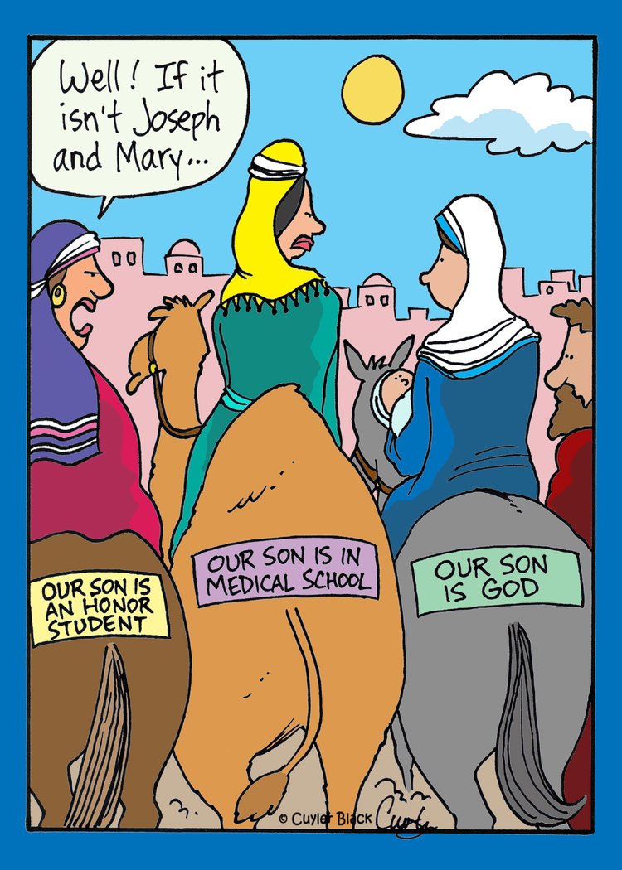

The birth of a child in a manger bring us to look for God’s arrival in our ongoing lives in each and every moment of our experiences rather than in some distant huge encounter. “Stay awake!“ is not a command involving an indeterminate future but a word for here and now.

**Prayers for Ourselves and Others and Lord’s Prayer** O God, we know that our prayers are the signs of our hope in you. Even as our faith is challenged by many things, even as we often do not know what to pray, we still seek to come into your presence trusting that you will listen and respond to us in love.  
And so we pray for those who are closest to our hearts this day and those whose place in the world is much fraught and troubled . Add your prayers to ours, Holy Spirit, for your wisdom is far beyond our knowing. Wait with us as we try to understand our part in the wellbeing of those who wait for love and compassion hoping for a world that cares enough to act with a new sense of justice and compassion. May we be your agents of freedom. Give to us an energy and passion for good change and faithfulness to never give up, even when we cannot see the way ahead.  
***Grant to us a spirit of adventure, O God, as we walk towards impossible dreams, for we know that nothing is impossible for you. This we pray in the name of Christ our Lord using the words he taught us  
 Our Father in heaven,  
 hallowed be your name,  
 your kingdom come,  
 your will be done,  
 on earth as in heaven.  
 Give us today our daily bread.  
 Forgive us our sins as we forgive those who sin against us.  
 Save us from the time of trial  
 and deliver us from evil.* *For the kingdom, the power, and the glory are yours  
 now and for ever.  
 Amen***

The day of the coming of Christ is every day.  
So let us now walk forward in Christ’s way.

**Benediction** May Christ be seen when we look behind us,  
 may the Spirit be found walking ahead to the fulfilling of our hopes  
 and God the Creator be known as love in all creation.

**Reverend Graeme Kerr**